### Electronics System

Table 6: List of sensors being used to measure atmosphere

|  |  |
| --- | --- |
| Parameter | Sensor |
| Temperature | RHT03 Temp. & Humidity sensor |
| Relative Humidity | RHT03 Temp. & Humidity sensor |
| Pressure | BMP180 Barometer |
| Solar Irradiance | Apogee Instruments SP-215 |
| UV Radiation | ML8511 UV sensor |
| Images | LinkSprite JPEG Color Camera |
| Accelerometer | ADXL345 |
| Data Transmission | XTend 900 1W RPSMA radio |
| GPS | Spark Fun Venus GPS |
| Micro Controller | Arduino Mega 2650 |
| Ground and PIL Antenna | Digi International A09-HSM-7 |
| Micro SD Card Board | SparkFun microSD Transflash Breakout |

## Science Value

### Payload Objectives & Success Criteria

#### The payload shall measure atmospheric data both during descent and after landing. For this objective to be successful pressure, temperature, relative humidity, solar irradiance and ultraviolet radiation measurements shall be taken. This data shall be taken at least once every second during decent and at least once every 60 seconds after landing.

#### The payload shall take at least 2 pictures during descent and 3 after landing. For this objective to be successful the sky and ground must be clearly discernable in all pictures.

#### The payload shall remain in orientation both during descent and after landing. For this objective to be successful the line of the horizon as viewed in the pictures taken by the payload shall not deviate more than ±40 degrees from a line parallel to the top and bottom frame of the picture.

#### The payload shall store all collected atmospheric data and pictures. For this objective to be successful 100 percent of all data and pictures taken by the payload shall be stored on the payload.

#### The payload shall transmit all data wirelessly to our ground station. For this objective to be successful 100 percent of all data taken by the payload shall be transmitted to our ground station.

#### A fairing shall be used to house and deploy the payload. For this objective to be successful the fairing shall completely separate to eject the payload while remaining tethered to the rocket.

### Experimental logic, approach, and method of investigation

This experiment will be carried out to further the scientific knowledge base of the atmosphere as well as improve the team's ability to communicate with atmospheric probes. The general approach is to build an atmospheric probe that will record and transmit data to a ground station. The data will be investigated through analysis of data with MATLAB. The investigation will compare plots of altitude vs. variables to known atmospheric models. The data will also be investigated visually and/or with additional software to look for abnormalities or points of interest that may occur. The camera data will be investigated visually for points of interest and future reference on the general sequence of events during launch. Any notes on points of interest, abnormalities, or launch sequence will be written in the post launch assessment briefing.

### Test and measurement, variables, and controls

To carry out our scientific objectives we will measure data from the following sensors: temperature, relative humidity, pressure, solar irradiance, UV radiation, cameras, accelerometers, and GPS. Data from all sensors except the camera will be gathered at 3 Hz. Camera data will be gathered 3 times during descent and 3 times on the ground.

All sensors except the camera will be used as dependent variables, except for pressure. After converting the pressure to altitude, it will be used as an independent variable for plots.

All sensors have been factory calibrated, providing a control to insure data accuracy. In addition, the pressure sensor on the launch pad before launch will be compared to the known altitude of the launch pad, allowing for an onsite calibration/control of our independent variable.

### Relevance of expected data and accuracy/error analysis

This data is expected to match known atmosphere models for all of the variables. Thus, our data will add to the scientific knowledge base and help to reinforce existing atmospheric models.

Data will be analyzed for error by comparing measured variables vs. altitude to expected variables vs. altitude based on known atmospheric models. Plots of error vs. altitude will be created for all measured data. Possible reasons for error will be discussed in a short section along with the plots.

### Preliminary Experiment Process Procedures

After collecting the data from all sensors on the PIL, the first step will be to process the pressure sensor and convert the measurements to altitude. This will be offset with the known control altitude at the launch pad gathered before launch. The corrected altitude will be used with our dependent variables to create plots in MATLAB. This data will be compared with expected plots based on known atmospheric models. Plots of error vs. altitude will be created for all variables. The final result will show the measured, expected, and error vs. altitude for all dependent variables.

The camera data will be processed by gathering data from the IMU allowing reorientation of the camera footage to level the horizon. This camera footage will analyzed by team members for scientific merit.

## Planetary Investigation Lander (PIL) Design and Integration

### PIL and Rocket Integration

On a larger overview, the PIL needs to integrate into the rocket, to where it is fixed enough to not deploy during launch, but loose enough to deploy when planned. To do this, the team has designed an adapter sleeve, which not only integrates the fairing into the rocket, but the inside of the sleeve will also house an inner retaining ring, as to allow the PIL to set inside of the adapter. This ring prevents the PIL from sliding deeper into the rocket when the rocket is experiencing high G load, but allows the PIL to deploy by sliding from the rocket though the fairing side of the vehicle, once the fairing has separated. Once the fairing deploys, the PIL’s parachute will automatically deploy, as it is planted above the PIL, between the fairing sections. As the PIL’s parachute deploys, the parachute will deploy, dragging the PIL out of the rocket. As the PIL exits the rocket, the rockets’ drogue parachute will be taped to the underside of the PIL, allowing the PIL to help deploy the drogue chute at the same time the PIL is deployed. In the event the PIL doesn’t deploy the rockets’ drogue parachute, a redundant charge will be set off to ensure the drogue parachutes’ deployment.

### PIL and landing module

The Landing module will be attached directly to the main structure with small screws extruding through one of the leg mounting holes directly into the tri-structure. This will ensure a sturdy landing module, and decreases the amount of angle brackets and screws needed to hold the landing module to the structure.

### PIL Protective Shell and Structure

The Protective shell that covers the rocket will be attached directly to the landing module. Screws extruding through the base plate of the landing module will thread directly into 3 equally spaced threaded nuts, epoxied onto the inside diameter of the protective shell. This will make servicing the PIL much easier as we can remove the Protective shell to service the electronics. The protective shell will also prevent any foreign objects from damaging our sensitive sensors.

### PIL and Ground Station

Ground Control will consist of a computer connected to an Arduino, which will be integrated to a radio transceiver. The ground control radio will communicate with the PIL radio, so we can send and receive commands and data.

electronics_diagram_PDR.emf

Figure 34: Diagram of Ground Control Payload Commination Hardware

## Planetary Investigation Lander (PIL) Electronics & Description

The electronics for the PIL will provide data and data transmission about the current atmospheric conditions to the Ground Control. Data will be collected by several sensors, and transmitted to ground control in real time via radio communication. An Arduino board will be the microcontroller used to interface the atmospheric sensors and radio. The Arduino program will constantly loop, collecting raw data from the sensors and transforming it into meaningful data (example - transforming the voltage generated from a pyranometer into solar irradiance using a known equation, relating voltage to solar irradiance). The meaningful data will be put into a JSON string and sent to ground control using the serial stream radio. When a photo is taken, a flag will be sent to the ground informing ground control that part of a JPEG image file is being sent. Part of the JPEG binary will then be sent. And end binary flag will be sent to ground when that part of the JPEG binary is ending, and the ground control will go back to parsing JSON data. We are sending only parts of a JPEG file at a time to continue measuring and sending atmospheric data, without spending too much time transmitting a whole JPEG file. The same data will also be written to a micro SD card on board the PIL as backup, in case of radio failure. The PIL will also scan for incoming radio signals from ground control. These radio signals, if existent, will contain actions for the PIL. These actions will include radio power adjustment and measurement frequency to conserve battery.

### PIL Electronics Components

* Arduino Mega 2650 - Microcontroller that interfaces with all sensors and the radio. The Arduino will collect the data from the sensors, create a JSON string from the data, and send the JSON string over serial to the radio. Binary data will be intermittently sent to the radio which corresponds to parts of a jpeg image when a photo is taken.
* XTEND-900 - Radio transceiver that receives and transmits an asynchronous serial stream.
* SparkFun Venus GPS - GPS Module that outputs GPS Coordinates over a serial connection.
* RHT03 - Temperature and Humidity Sensor. After testing, we discovered only one is needed. Data is able to be captured at a frequency of at least 3HZ. Data is sent over a single wire interface.
* BMP180 - Barometer sensor. Sends barometric pressure over an I2C connection. The barometric pressure can be used to report altitude as well.
* ML8511 - Ultraviolet light sensor. This sensor continuously streams a voltage between 0V and 3.3V that represents the amount of UV light.
* Apogee Instruments SP-215 - Pyranometer. The pyranometer continuously streams a voltage between 0V and 5V that represents solar irradiance.
* ADXL345 - Accelerometer sensor. Sends acceleration data over an I2C connection.
* LS-Y201-2MP - JPEG Color camera that outputs JPEG data over a serial connection.
* SparkFun microSD Transflash - microSD Breakout board to write data to microSD. Backup data storage in case of radio failure.
* Custom PCB – This PCB will hold the SparkFun Venus GPS, RHT03, BMP180, ADXL345 and SparkFun microSD Transflash. This will allow a neat organization of wires, and reduce risk of connection failures.

### PIL Electronics Testing

* Arduino Mega 2650 – Verify the Arduino can communicate with all sensors. This has been ordered and has been sucesfully tested with several sensors.
* XTEND-900 – Test radio connection between PIL and Ground Control. This has been successfully tested for short range radio communication.
* SparkFun Venus GPS – Test GPS and verify location outputted with current location.
* RHT03 – Test and verify temperature and humidity are within expected range. This has been ordered and has been successfully integrated and tested with the Arduino.
* BMP180 – Test pressure on ground and verify it is within expected range. This has been ordered and has been successfully integrated and tested with the Arduino.
* ML8511 – Test sensor by covering the sensor to prevent any light from entering, then uncover in sunlight. Verify UV intensity increased with sunlight. This has been ordered and has been successfully integrated and tested with the Arduino.
* Apogee Instruments SP-215 – Test sensor by covering the sensor to prevent any light from entering, then uncover in sunlight. Verify solar irradiance increases with sunlight.
* ADXL345 – Test data outputted from accelerometer by standing the sensor upright. Verify acceleration of gravity (z axis) is close to 9.81 M/S2. Verify x and y axis is close to 0 M/S2 (no gravity on x and y axis when upright). This has been ordered and has been successfully integrated and tested with the Arduino.
* LS-Y201-2MP – Test photo capture and transmission. Verify JPEG data is fully transmitted and can be displayed on a computer. This has been ordered and has been successfully integrated and tested with the Arduino.
* SparkFun microSD Transflash – Test file creation and writing abilities. This has been ordered and has been successfully integrated and tested with the Arduino.
* Custom PCB – Test trace continuity to verify all connections are made.

### PIL Electronics Launch Day Checklist

Verify batteries for PIL are charged.

Test radio connection between PIL and Ground, and verify strong signal strength.

Test GPS System and verify reported GPS is within expected area.

Test all sensors using ground control software.

Test MicroSD card. Verify file read and write works on both Arduino and computer.

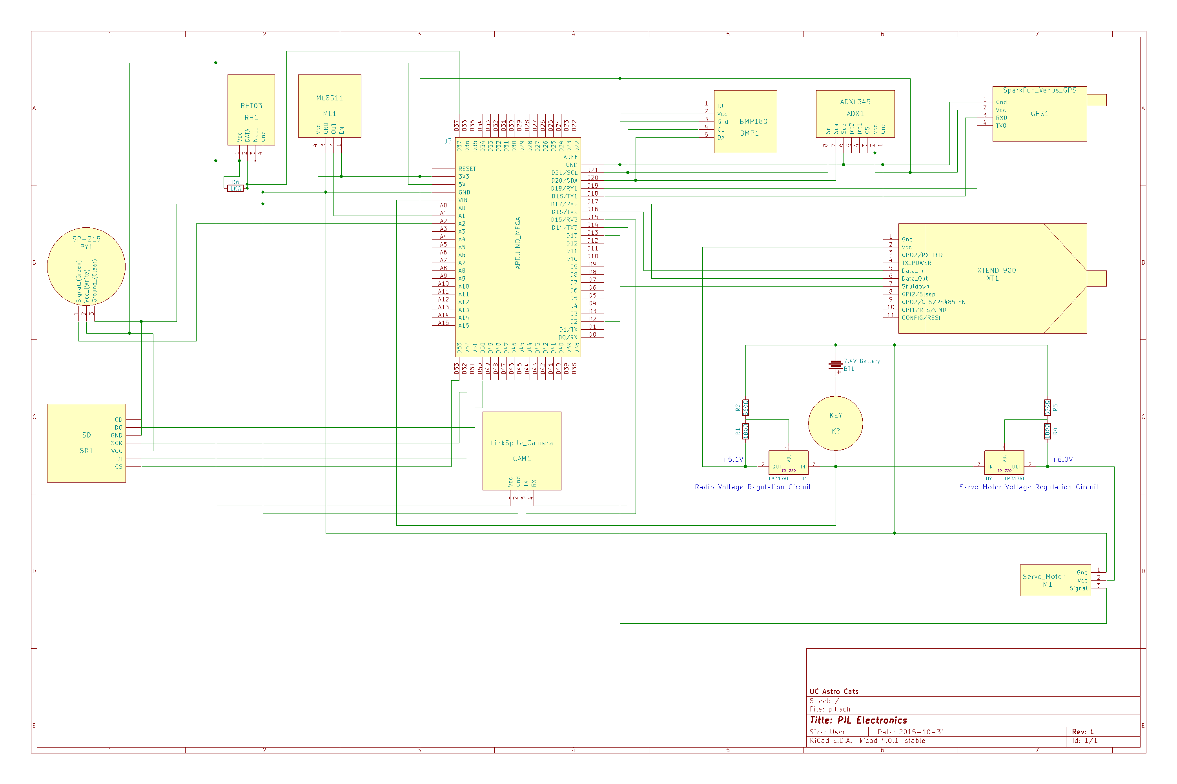

Figure 35: PIL Electrical Schematic

RHT03 output to Arduino

RHT03 – Temperature and Humidity

UV Sensor output to Arduino

ML8511 – UV Sensor hookup

Pullup resistor

MicroSD inputs and outputs to and from Arduino

MicroSD card

BMP180 - Barometer

ADXL345 - Accelerometer

SparkFun Venus GPS

Voltage dividing resistors

Inputs and outputs to and from Arduino

SP-215 - Pyranometer hookup

LS-Y201-2MP – Camera hookup



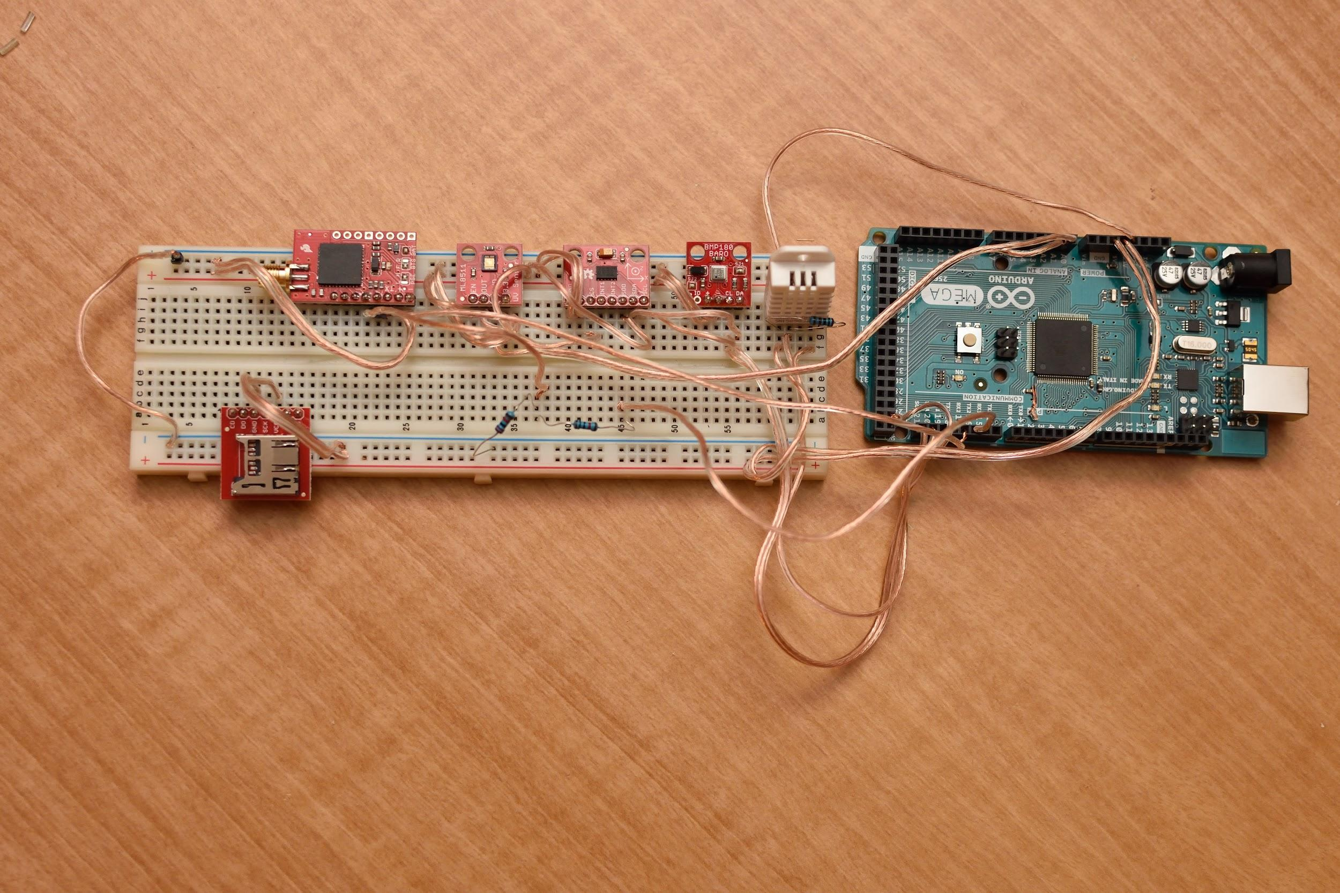

Figure 36: PIL Breadboard Prototype

## Ground Support Electronics & Description

The ground control will receive and display data obtained from the PIL and Rocket tracking bay on a PC. Incoming data will be either JSON data or binary data. JSON data will be parsed and the user interface will be updated based on the new values that were received. Binary data that is parts of a JPEG file will be collected and when the end of JPEG file is detected, ground control will put together all parts of the JPEG file, decompress and display the image. The ground control will also be capable of sending commands to the PIL. These commands will include radio power adjustment and measurement frequency to conserve PIL battery. The ground control will consist of a PC, an Arduino board and a radio transceiver. Custom software will be developed that displays the data obtained from the PIL and Rocket Tracking Bay graphically and numerically. The data will be written to disk as it is collected for further analysis.

### Ground Control Electronics Components

* Arduino Mega 2650 – Microcontroller that interfaces the radio transceiver with the PC. Sends incoming radio data from the PIL and Tracking Bay to the PC, and sends outgoing commands to the radio, to transmit to the PIL.
* XTEND-900 – Radio transceiver that receives and transmits an asynchronous serial stream.
* PC – A laptop used to interface with the Arduino to display gathered data using custom software. The ground control software will parse the incoming JSON data or binary data, and update the user interface to display the new values received. The intermittently collected binary data will be put together once the end of a JPEG is detected, and the JPEG image will be decompressed and displayed on the ground control user interface.

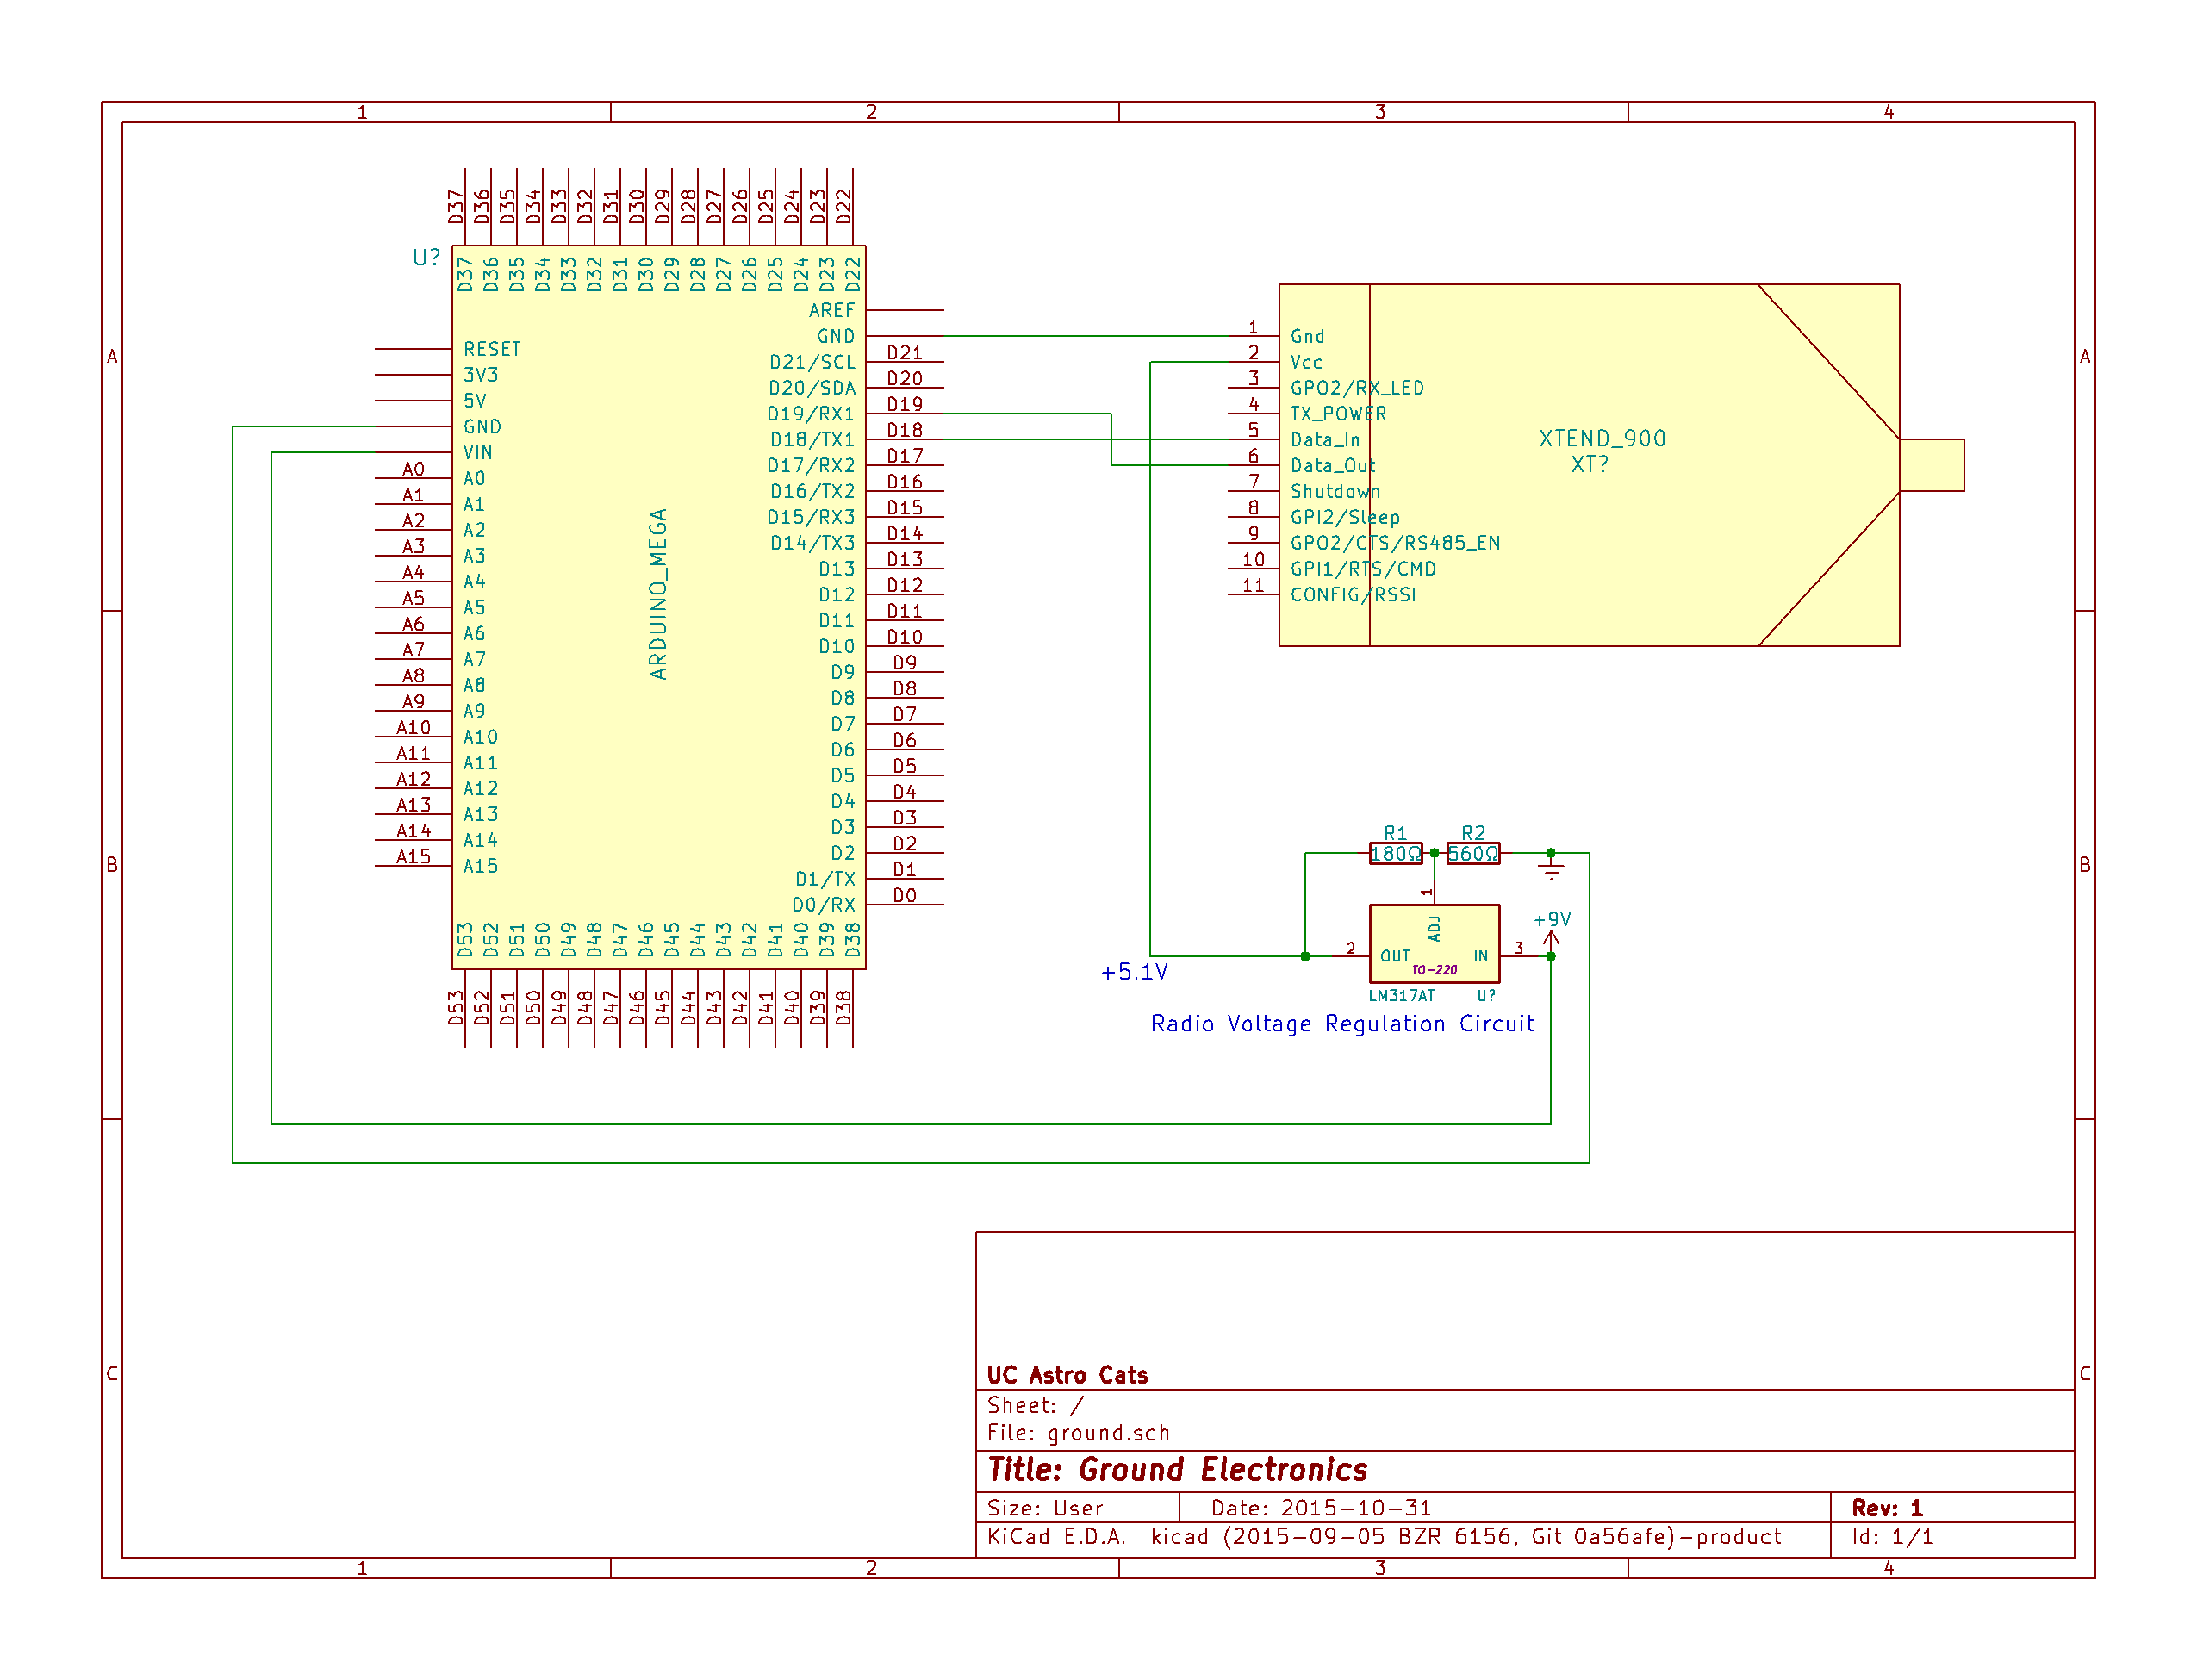

Figure 36: Ground Station Wiring Schematic

### Ground Control Software

The ground control software development has been started. The ground control software is being written in C++, using wxWidgets for the GUI library. A serial port reading thread is able to read the data from the Arduino, and a user interface update thread parses the data from the serial port, and updates the display. The following displays development have been started: radio signal strength from PIL and rocket, temperature, humidity, UV intensity, solar irradiance, air pressure and altitude, and pitch and roll display (orientation of PIL relative to the ground).

The ground control software can also record and playback data. This will be our main point of data collection, with the SD card on the PIL as a backup. The data collected will be analyzed after launch, and can be played back with the GUI for visual analysis and testing.

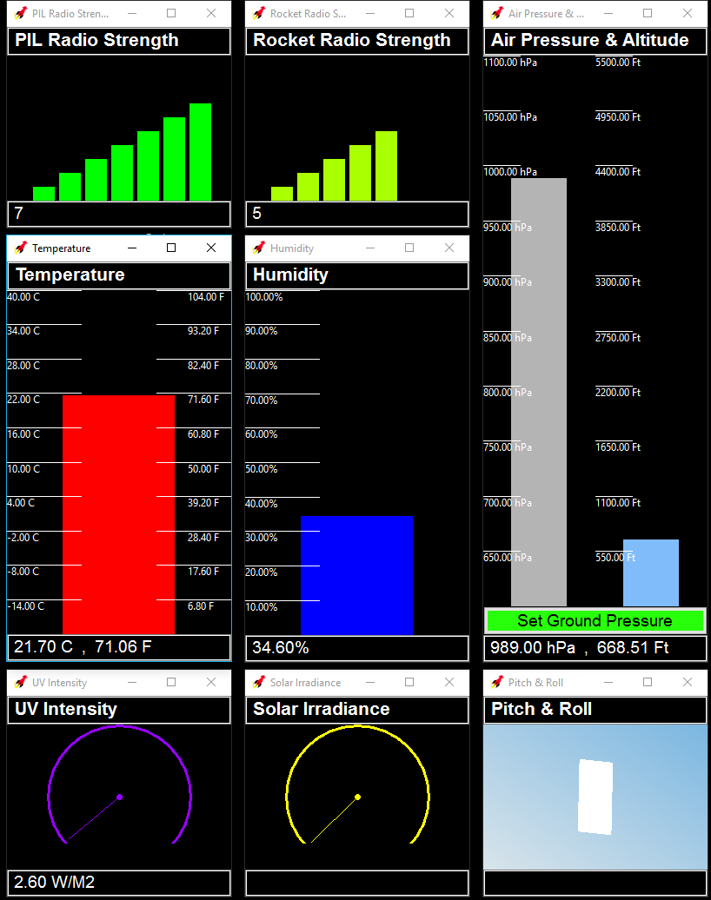

Ground Control Gauges – This displays the latest data captured from the PIL.

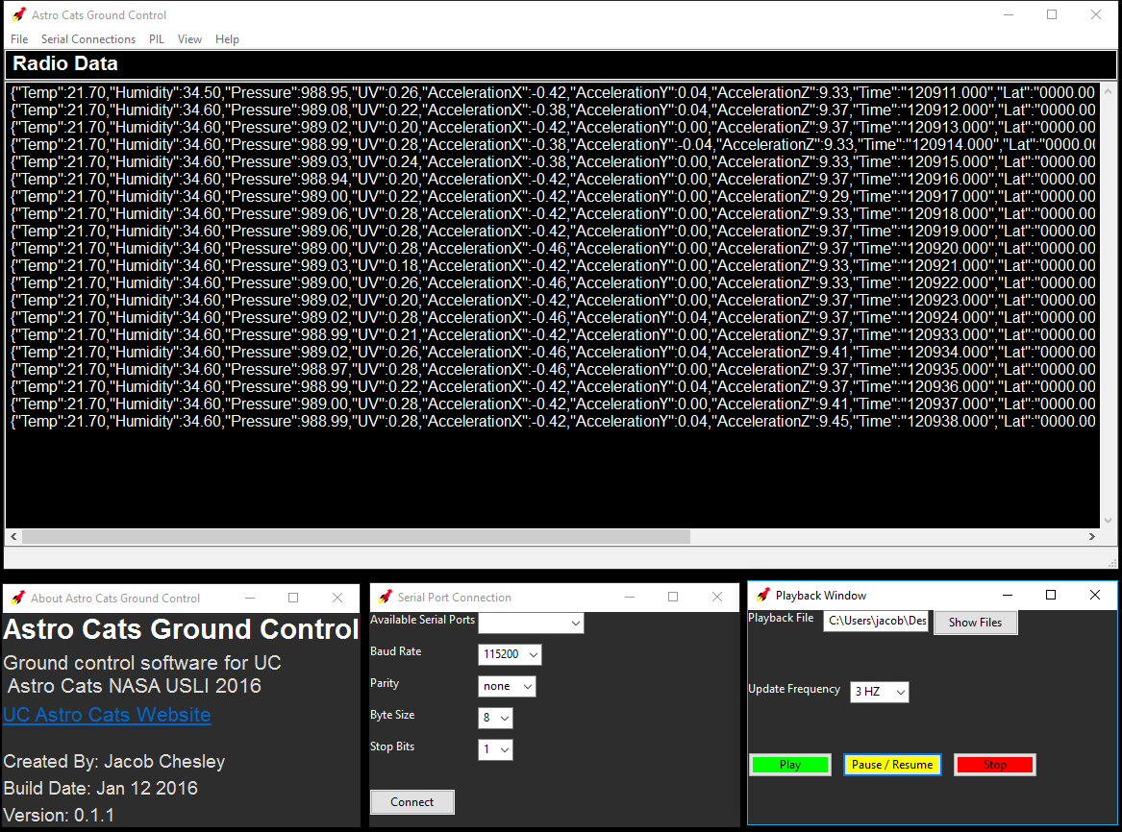

Ground Control Main Window (top), About Window (bottom left), Serial Port Connection Window (bottom middle), and Playback Window (bottom right).